**DAY 5 - Testing, Error Handling, and Backend  
Integration Refinement**

**1. Overview**

In this phase, the focus was on performing testing, refining error handling, and improving the backend integration for the project. The objective was to ensure the smooth functionality of the website, detect and resolve any errors, and ensure seamless communication between the frontend and backend systems.

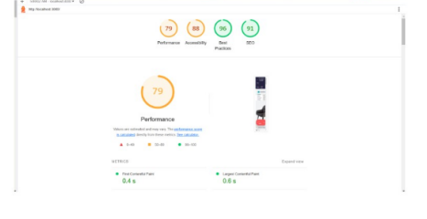

• Responsive Design: Verified that the website is responsive across devices.  
◦ Example: Tested on mobile, tablet, and desktop.  
◦ Result: No layout issues detected.  
• API Integration: Checked all API endpoints for proper functionality.  
◦ Example: Product listing API working correctly.  
◦ Result: Data is fetched and displayed without errors.

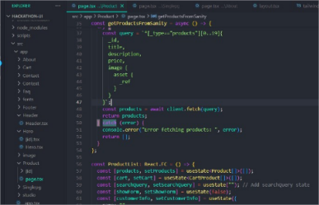

**2. Security Measures**

• Steps Taken:  
○ Secured API endpoints with proper authentication.  
○ Used HTTPS for secure data transfer.  
○ Validated and sanitized user inputs to prevent attacks.  
○ Result: No vulnerabilities found during testing.

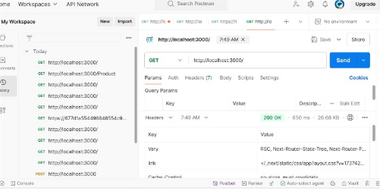

**3. Challenges and Solutions**

• Challenge: Slow API response affecting the user experience.  
◦ Solution: Added caching to reduce API load time.  
• Challenge: Minor layout shifts on mobile devices.  
◦ Solution: Adjusted styles for better alignment.

**4. Final Results**

• Website performs well across all devices.  
• APIs are working as expected with proper error handling.  
• Security measures ensure the application is safe.  
• All challenges resolved, delivering a smooth user experience.  
Final Scores:  
• Performance: 79  
• Accessibility: 88

• Best Practices: 96  
• SEO: 91